PANEL OF MANAGAMENT IN DJANGO

Groups and users are models by default provided by django

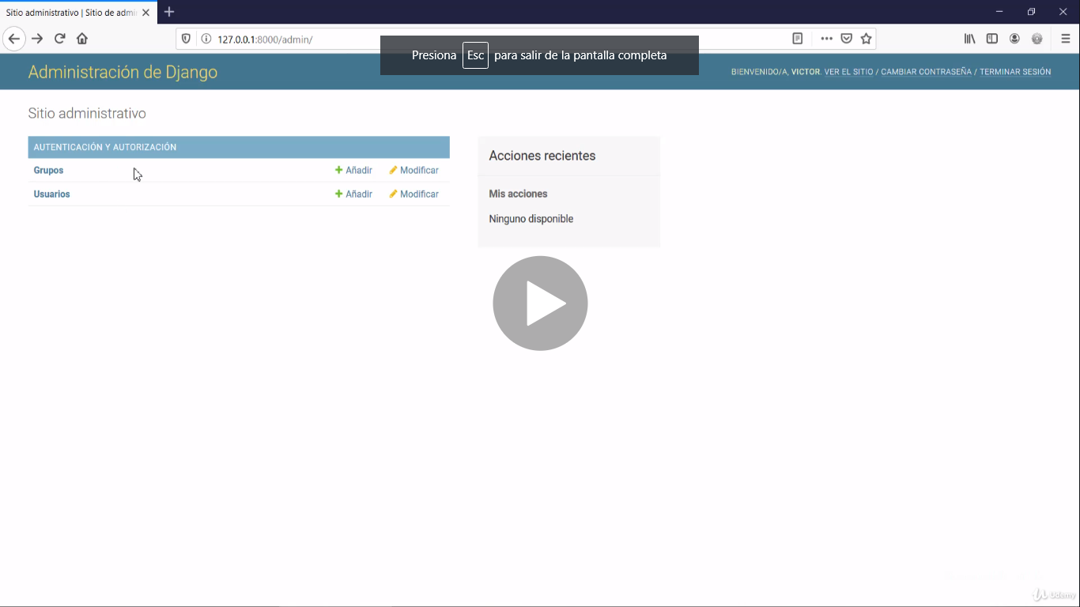

After to register will appear models of miapp

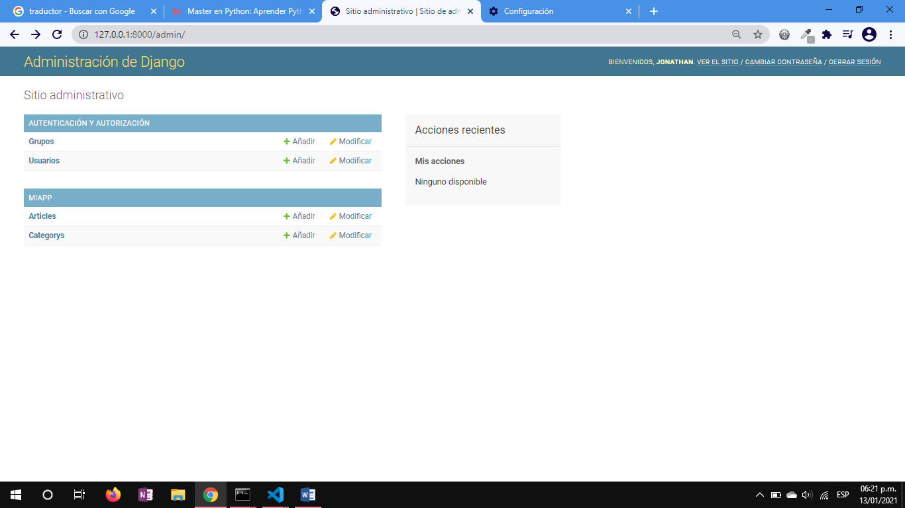

Creating a new category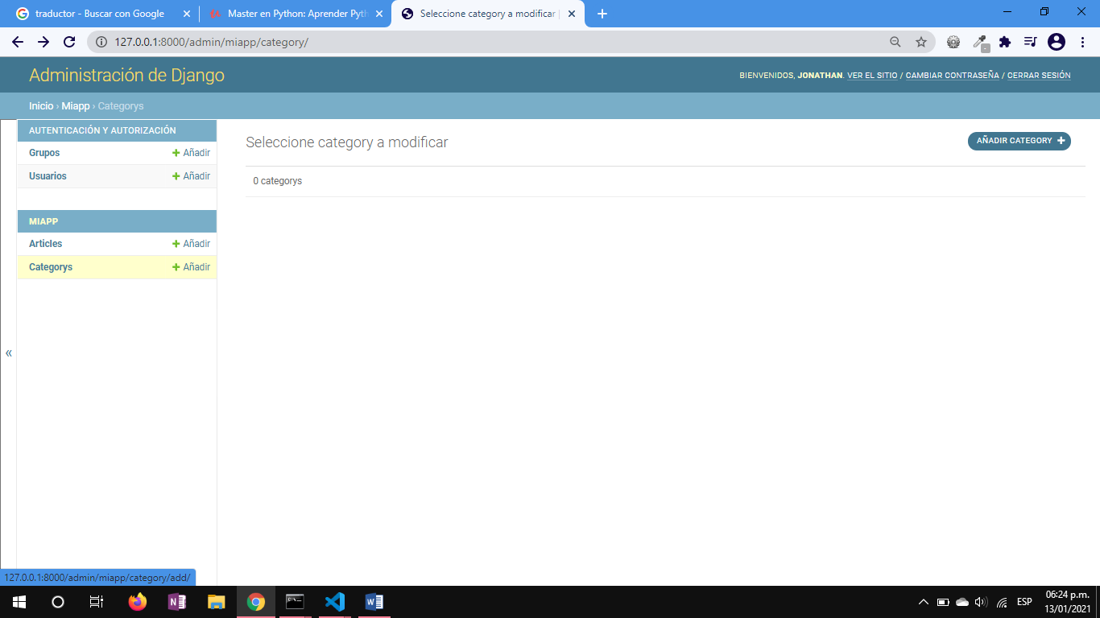

DJANGO PLURALIZA EL NOMBRE DE LOS MODELOS

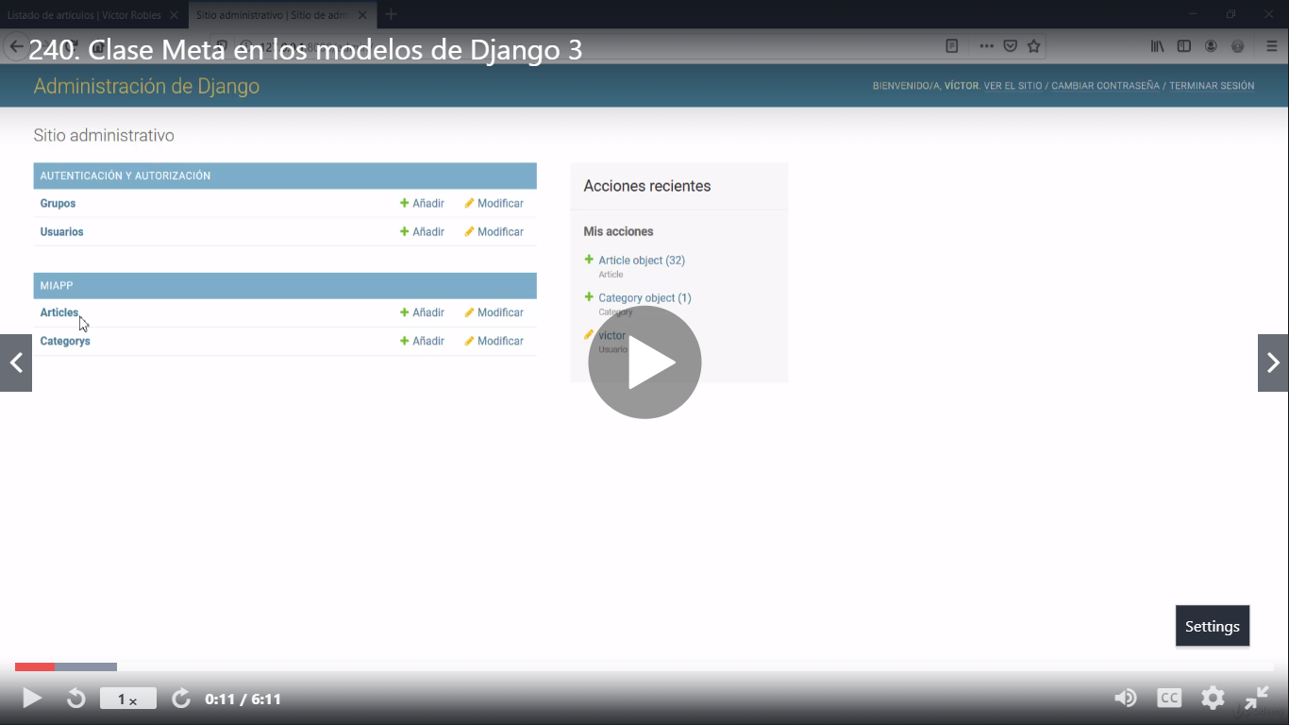

After to use class Meta, name of my models have changed

